**EXPERIMENT 1:**

**Name: M.S.SANJAY Reg NO.: 15BCE0517 SLOT: L31+L32**

a=45 a

[1] 45

b=50 b

[1] 50

(a/b)^2 [1] 0.81 **sqrt**(a*b)

[1] 47.43416 **Taking logarithm**

lna=**log**(a) lna

[1] 3.806662 **Anti-log exp**(lna)

[1] 45

*# Total product* n=500

*# No of defectives* d=50

*# Proportion* p=d/n p

[1] 0.1

***Creating a vector (Combining each elements)***

id=**c**(1,2,3,4,5,6,7,8,9,10) id

[1] 1 2 3 4 5 6 7 8 9 10

age=**c**(22,25,21,20,19,18,15,22,16,19) age

[1] 22 25 21 20 19 18 15 22 16 19

sex=**c**('M','F','F','M','F','M','M','F','M','M') sex

[1] "M" "F" "F" "M" "F" "M" "M" "F" "M" "M"

smk=**c**(1,0,1,0,1,0,0,0,1,0) smk

[1] 1 0 1 0 1 0 0 0 1 0

***Value labelling***

sex=**type.convert**(

sex

[1] M F F M F M M F M M

Levels: F M

smk=**factor**(smk,labels=**c**('Non-Smoker','Smoker')) *#Creating new labeling*

smk

[1] Smoker Non-Smoker Smoker Non-Smoker Smoker Non-Smoker

[7] Non-Smoker Non-Smoker Smoker Non-Smoker

Levels: Non-Smoker Smoker

***Subsetting a vector***

sexm=**subset**(sex,sex== sexm

[1] M M M M M M

Levels: F M

***Creating a data frame (Combining vectors)***

eg=**data.frame**(id,age,sex,smk) *# Data is saved in the object ‘eg’* eg

id age sex smk 1 1 22 M Smoker

1. 2 25 F Non-Smoker
2. 3 21 F Smoker
3. 4 20 M Non-Smoker
4. 5 19 F Smoker
5. 6 18 M Non-Smoker
6. 7 15 M Non-Smoker
7. 8 22 F Non-Smoker
8. 9 16 M Smoker

10 10 19 M Non-Smoker

**Subsetting a data**

egf=**subset**(eg,eg$sex *from particular data* egf

id age sex smk

1. 2 25 F Non-
2. 3 21 F Smoker

5 5 19 F Smoker

8 8 22 F Non-

|  |  |
| --- | --- |
| ***Summary of data*** | id age sex smk  Min. : 1.00 Min. :15.00 F:4 Non-Smoker:6  1st Qu.:18.25 M:6 Smoker :4 Median : 5.50 Median :19.50  Mean : 5.50 Mean :19.70 rd Qu.: 7.75 3rd Qu.:21.75 |
| **summary**(eg)      1st Qu.: 3.25      3  Max. :10.00 Max. :25.00 |

|  |  |
| --- | --- |
| ***Summary of a vector*** | Min. 1st Qu. Median Mean 3rd Qu. Max.  18.25 19.50 19.70 21.75 25.00 |
| **summary**(eg$age)    15.00 **mean**(eg$age) [1] 19.7 **sd**(eg$age)  [1] 2.983287 |

|  |  |  |
| --- | --- | --- |
| ***One-way table*** | )    4  (tab1)    0.4 | # Percentage for the table |
| tab1=**table**(eg$smk tab1  Non-Smoker Smoker  6  ptab1=**prop.table** ptab1  Non-Smoker Smoker  0.6 |

|  |  |  |
| --- | --- | --- |
| ***Two-way table*** | eg$smk,eg$sex)  F M      (tab2) *# Over all percentage*    F M      (tab2,1) *# Row percentage*    F M  Smoker 0.3333333 0.6666667  Smoker 0.5000000 0.5000000  (tab2,2) *# Column percentage*  F M  Smoker 0.5000000 0.6666667 Smoker 0.5000000 0.3333333 | |
| tab2=**table**( tab2  Non-Smoker 2 4 Smoker 2 2  ptab2=**prop.table** ptab2  Non-Smoker 0.2 0.4 Smoker 0.2 0.2  rptab2=**prop.table** rptab2  Non-    cptab2=**prop.table** cptab2    Non- |
| ***Saving the dataset*** | |  |
| **save**(eg,file="eg") | |

|  |  |
| --- | --- |
| ***Open the 'R' Dataset*** |  |
| **load**("eg")  eg  id age sex smk 1 1 22 M Smoker 2 2 25 F Non-Smoker 3 3 21 F Smoker 4 4 20 M Non-Smoker 5 5 19 F Smoker 6 6 18 M Non-Smoker   1. 7 15 M Non-Smoker 2. 8 22 F Non-Smoker 9 9 16 M Smoker 10 10 19 M Non-Smoker |

|  |  |
| --- | --- |
| ***Exporting R dataset*** | )      Smoker    Smoker  Smoker  Smoker  Smoker oker Smoker |
| **write.csv**(eg,"eg.csv")    ***Importing files into R***    dat1=**read.csv**("eg.csv" dat1  X id age sex smk 1 1 1 22 M Smoker   1. 2 2 25 F Non- 2. 3 3 21 F Smoker 3. 4 4 20 M Non- 4. 5 5 19 F Smoker 5. 6 6 18 M Non- 6. 7 7 15 M Non- 7. 8 8 22 F Non- 8. 9 9 16 M Sm 9. 10 10 19 M Non- |

**R Graphs**

|  |  |
| --- | --- |
| ***Line plot*** | "l", *# Specify type of plot as l for line* "Age of subjects",  "Id",  "Age in Years", "Red" |
| **plot**(eg$age, type= main= xlab= ylab= col= ) |

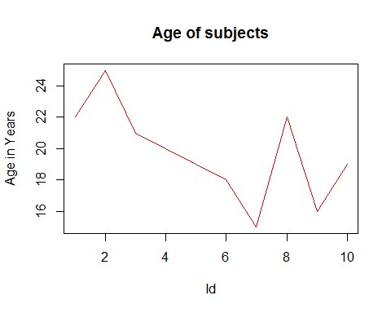

|  |
| --- |
| **plot**(**subset**(eg$age,eg$sex=='M'),  type="l", *# Specify type of plot as l for line* main="Age of subjects", xlab="Id", ylab="Age in Years", col="Red"  )  **lines**(**subset**(eg$age,eg$sex=='F'),col="blue") |

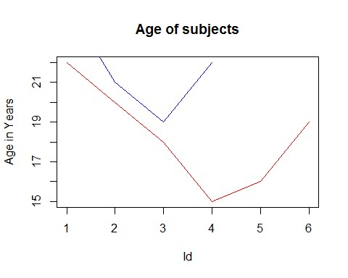

|  |  |
| --- | --- |
| ***Pie chart*** | (eg$smk) |
| tab1<-**table pie**(tab1) |

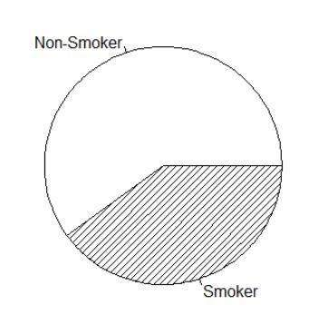

|  |  |
| --- | --- |
| ***Bar graph*** | (eg$smk,eg$sex) tab2, beside=T, *# Multiple bar*  xlim=**c**(1,8), *# X-axis range*  ylim=**c**(0,5)) *# Y-axis range*  "topright", *# Position of legend* legend=**rownames**(tab2), *# Legend names* fill=**c**("Black","grey"), *# Color to be filled*  "n") |
| tab2=**table barplot**(      **legend**(  bty= |

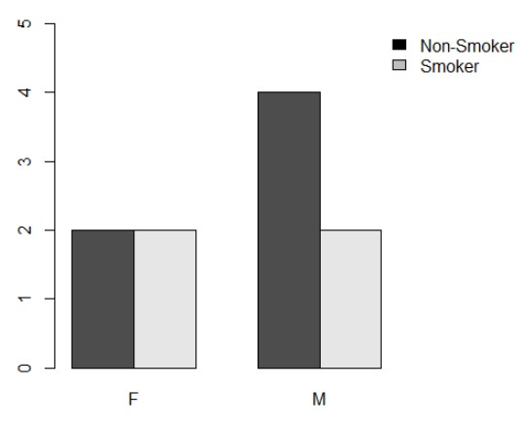

|  |  |
| --- | --- |
| ***Box plot*** | eg$age~eg$smk,col=**c**("maroon","turquoise3")) *# for color names* |
| **boxplot**( *'colors()'* |

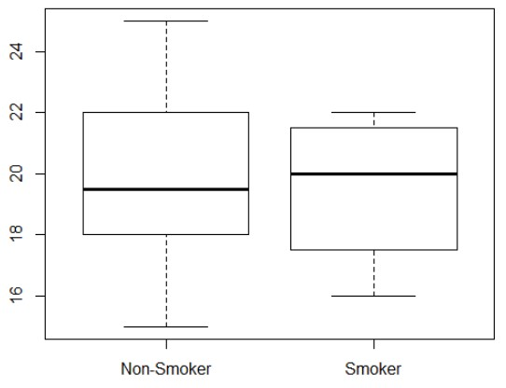

|  |  |
| --- | --- |
| ***Histogram*** | *45,25,39,45,36,35,36,45,34,39,51,41,38,32,45)*    *curve(dnorm(x,mean=mean(failure),sd=sd(failure)),add=T)* |
| *failure<-****c****( hist(failure,prob=T)* |

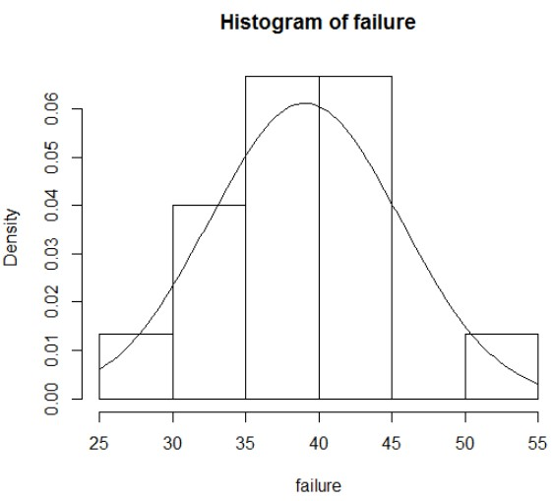

|  |  |
| --- | --- |
| ***Checking normality using Shapiro-Wilks test*** |  |
| **shapiro.test**(failure)  Shapiro-Wilk normality testdata: failure  W = 0.9659, p-value = 0.7938 |

|  |  |
| --- | --- |
| ***Scatter plot*** | resistance,failure,col="black",pch=16) failure~resistance),col="black") |
| **plot**( **abline**(**lm**( |

